Step1:

Downloaded the data from the ‘cricsheet.org’ where each ‘match’ data is present in a csv file format.
Written code to extract data ball-by-ball for each of the matches and merged them together into one single aggregated sheet. All the possible data is extracted.

The following fields were extracted.
- Inning_Number
- Batting_Team
- Batsman
- Non_Striker
- Bowler
- Runs_off_Bat
- Extras
- Wides
- No_Balls
- Byes
- Leg_Byes
- Penalty
- Kind_of_wicket_If_Any
- Dissmissed_Player_When_Wicket
- city
- gender
- date
- toss_winner
- toss_decision
- venue
- Team1
- Team2
- match_id
- Over
- Ball
- match_date
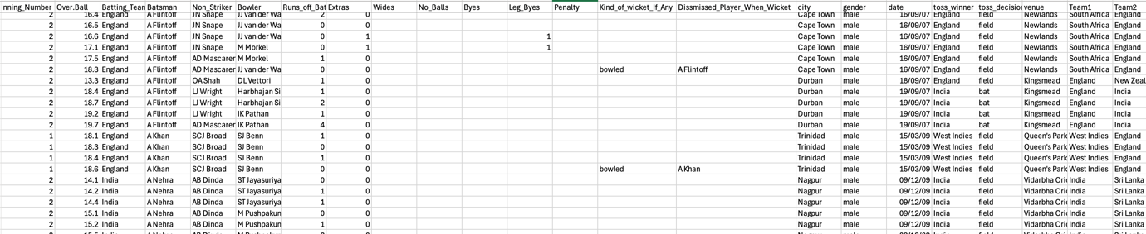

No in-order to know the properties of the player, have extracted the batsman/bolwer features below from the ‘expncricinfo.com’ by scrapping the website using the ‘Octoparse’ tool. Extracted data for all the main team players.
- Playing role in team - Batter/Bowler/Allrounder
- Batsman_hand – Right/left
- Bowling_hand – right/left
- Bowling_style – Fast/Medium/Offspin/Legspin etc

Teams which were considered are ‘Australia, SouthAfrica, India, Pakistan, Bangladesh, Srilanka, Zimbabwe, Afganistan, New zealand, England’.

Now from this ball-to-ball data the cumulative player stats are calculated for a Batter and Bowler separately at a match level.

The cumulative fields for the batter look like below:

- Batsman: The name of the batsman.
- match_id: A unique identifier for each match.
- Innings: The number of innings the batsman played in the match.
- Runs scored: The total runs scored by the batsman in that match.
- Balls faced: The number of balls the batsman faced in the match.
- Batting Strike Rate (SR): The strike rate of the batsman.
- No. of Sixes: The number of sixes hit by the batsman.
- No. of Fours: The number of fours hit by the batsman.
- dismissal: Indicator if the batsman was dismissed.
- Batting hand: The batting hand (e.g., Left or Right).
- Coreskill: Indicates whether the player is a batter or both a batter and bowler.
- Match_date: The date of the match.
- No of Right hand bowlers_faced(RHBo): The number of right-hand bowlers faced.
- No of left hand bowlers_faced(LHBo): The number of left-hand bowlers faced.
- No of Off Spinners_faced(OffspinBo): The number of off-spin bowlers faced.
- No of leg Spinners_faced(LegspinBo): The number of leg-spin bowlers faced.
- No of Fast pace Bowlers_faced(FastBo): The number of fast pace bowlers faced.
- No of Medium pace bowlers_faced(MediumBo): The number of medium pace bowlers faced.

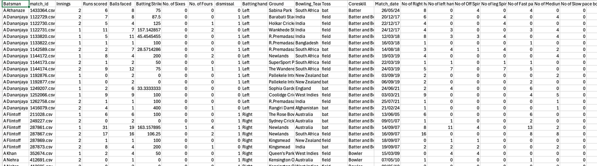

Data inconsistencies were handled especially when there are name mismatches for players in the two data sources information. They were few and are manually handled.

Missing values were treated based on the variable. But almost all the data for the main variables extracted from the ball-to-ball is good. Missing values have to be treated for only calculated values like batting strike rate against an opposition etc.

X and Y variables were defined on the basic data.
X being all the variable defined above and Y being the ‘next_match_runs’. The basic linear regression model showed very poor R2 value.

So went on to define the additional features to define the form, opposition, ground and lastfew matches performance. But none of them helped to improve the model.

Ran Random forest and linear regression models by adding different additional features.

Tried to include the techniques like ‘principal component analysis’ and then also tuning the random forest parameters but the performance is not improving.

Model performance with basic cumulative fields:

Linear regression:
Mean Squared Error: 361.22341454344274
R² Score: 0.2558959744070271

Random forest Regressor:
Mean Squared Error: 366.80223538485006
R² Score: 0.3519707793253017

The model is more accurate when not considering the cumulative parameters as they are creating randomness to the data, we have increased co-relations among the cumulative valriables.

Overall we experimented 3 ways of modelling
- one to see the factors impacting the match performances.
- Group the data as mentioned about at player and match level, introducing and removing factors and then calculating running the models
- Predicting player performances at match, bowler and batter level that is performances each other using which the next match runs/wickets of players can be assessed.

Finally we settled with the model 2 which uses the minimum variables like runs, strike rate and economy rate for a batsman wheres as wickets, bowling economy, bowling average for bowlers to predict each of the other variables. This would help us assess selectors to assess the players to be selected for the upcoming matches.

